Exter, Alexandra Alexandrovna Grigorovich (1882-1949)

ABSTRACT

Alexandra Exter was an influential Russian modernist painter and designer. Very much a part of modernist trends – Cubism, Simultaneism – in Paris, Exter brought their ideas to her friends in Russia, thereby contributing to the rise of modernism and the Russian avant-garde. She was a major contributor to the stream of modernism that explored colour and its laws. . Although she played a significant role in the development of the early Soviet art scene, the political situation motivated Exter to emigrate to Paris in 1924, where she taught composition and colour in the studio of Fernand Léger, the Académie Moderne (1925-1929) while also teaching theatre design in her own studio.

TEXT

Born on 6 January 1882 in Bialostok, Belorussia, Imperial Russia, Exter first exhibited in the Kiev avant-garde exhibition “The Link” [Zveno, 1908], showed paintings in a pointillist style that she had created in 1907 in France and Switzerland. After passing through a brief Cézanne-influenced period, during 1911 and 1912 she adopted the structural principles of Cubism. During 1913-1915, she took up the colour ideas of Parisian Simultaneism from Robert Delaunay, Sonia Delaunay and the Synchromists. For these artists, colour is what the eye sees before it sees objects, making the world a fantastic display of shapes of moving colour shifting between light and dark. They depicted this display in their paintings (e.g. R. Delaunay, Solar Disc, 1912; S. Delaunay, Le Bal Bullier, 1913). Exter captured the city at night in a series of paintings that became increasingly non-objective as patches of colours began to predominate over objects. Returning to Russia in 1914, she was associated with the Cubo-Futurist painters – K. Malevich, L. Popova, et al. – and in 1916, like these and other artists, she was using spinning discs to capture moving colour in light. Exter’s “Dynamism of Colour” series (1916-1918) was entirely non-objective and was followed by her “Colour Constructions” (composed with beams of light from projectors onto a screen [1920-1924]) and the “Dynamics of Colour” series (using the circular movement of machines). She was a major contributor to the stream of modernism that explored colour and its laws.
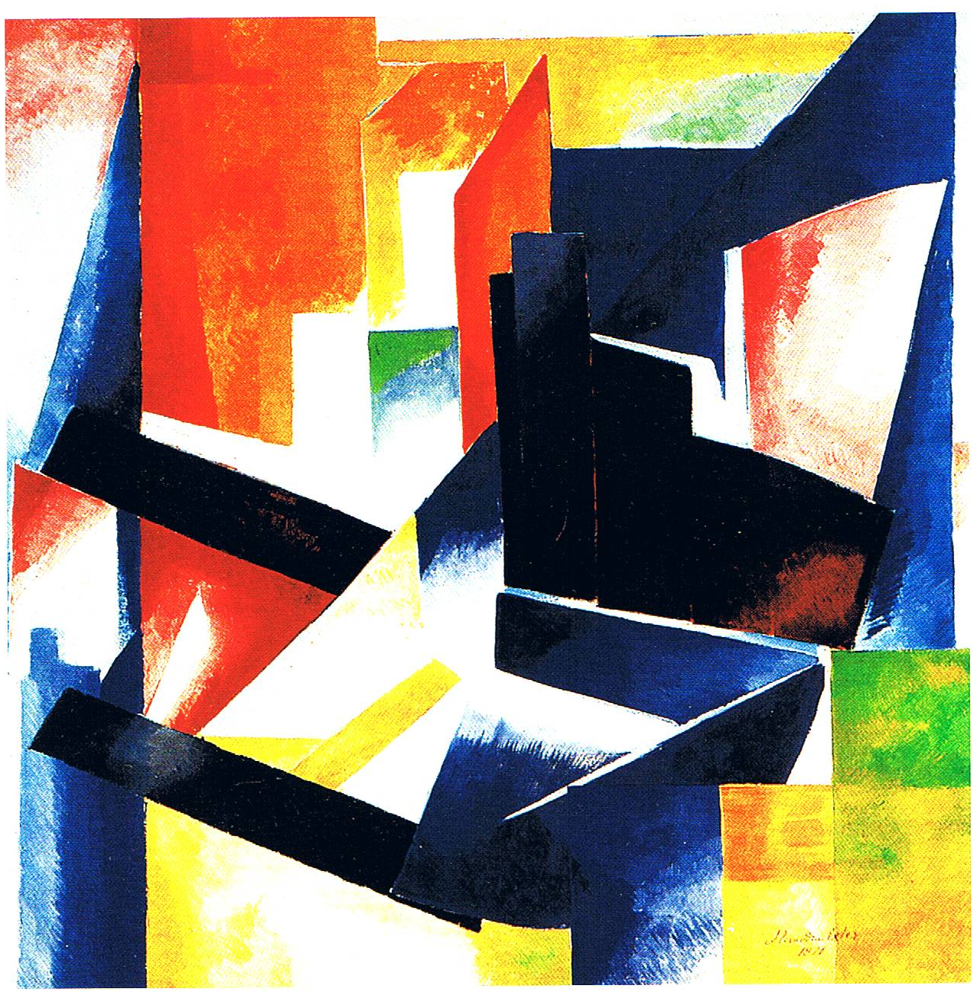
Colour Construction, 1921 Oil on canvas, 89 x 89 cm. State A. Radichev Museum of Art, Saratov

Very much a part of modernist trends – Cubism, Simultaneism – in Paris, Exter brought their ideas to her friends in Russia, thereby contributing to the rise of modernism and the Russian avant-garde. Because of the First World War and then the 1917 October Revolution, Exter remained based in Russia during the early 1920s, where she not only took part in exhibitions of non-objective art but also became engaged in costume and set design for the theatre (Thamira Kitharides, 1916, Salome, 1917, Romeo and Juliet, 1921 for Alexander Tairoff and his Kamerny Theatre, Moscow), and for film (J. Protozanov’s, Aelita, 1924). Living in Kiev from 1917 to 1918, she was involved in arts programmes for the Bolshevik regime. In an official capacity she was responsible for installation of the Russian section at the Venice Biennale (1924) and the Paris Exposition des Arts Décoratifs et Industriels Modernes (1925), where she was awarded a gold medal for her theatre work. The political situation in Russia motivated Exter to emigrate to Paris, where she began to paint in the Purist style and taught composition and colour in the studio of Fernand Léger, the Académie Moderne (1925-1929) while also teaching theatre design in her own studio. In the 1930s she added book design to her design pursuits. She died on 17 March 1949 in Fontenay-aux-Roses, near Paris.

References and further reading:
Yakov Tugenhold, Alexandra Exter, Berlin: Saria, 1922 (in Russian, German, French).
Jean Chauvelin, Nadia Filatoff, with John Bowlt, Dmytro Horbachov, Alexandra Exter,
Paris: Max Milo Editions, 2003.
Gyorgy Kovalenko, Alexandra Exter, 2 vols., Moscow: Museum of Modern Art, 2010.
Patricia Railing, Alexandra Exter Paints, Forest Row: Artists Bookworks, 2011.

